Artist Colette Miller created the Global Angel Wings Project

* 8401 W 3rd St, Los Angeles 90048, another at 453 Colyton Street

Collaboration between Christina Angelina (@starfightera) and Fanakapan. (@fanakapan)

* Arts District, Downtown L.A. @ 4th Street and Merrick, LA 90012

American Tropical

* *125 Paseo De La Plaza*
* Artists is David Siqueiros who left Mexico and came to Los Angeles. Mexican Indian crucified on a cross underneath an American eagle with Mayan pyramids and other Latin American symbols in the background. The piece was created as a political statement about US Imperialism in Latin America. Mural is almost 100 years old as the Getty has worked against time to bring this piece back to life.

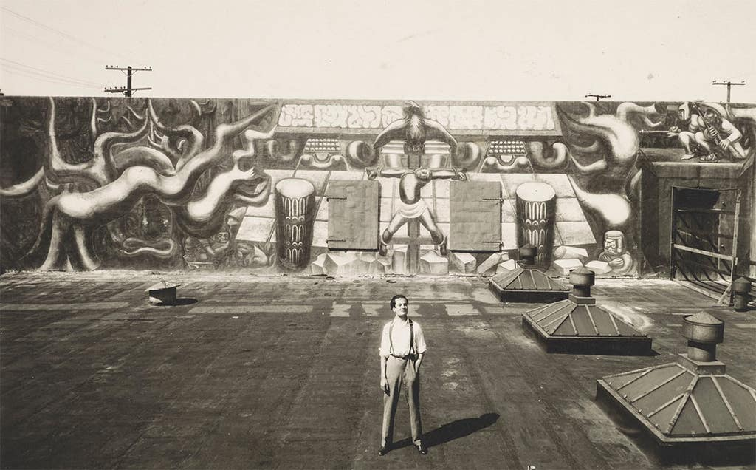

##### Skid Row Mural

##### 6th Street and San Julian Street

* voted as the best new street art piece in LA a few years ago. One of the things that makes this piece so special is that it is completely created by residents of skid row
* 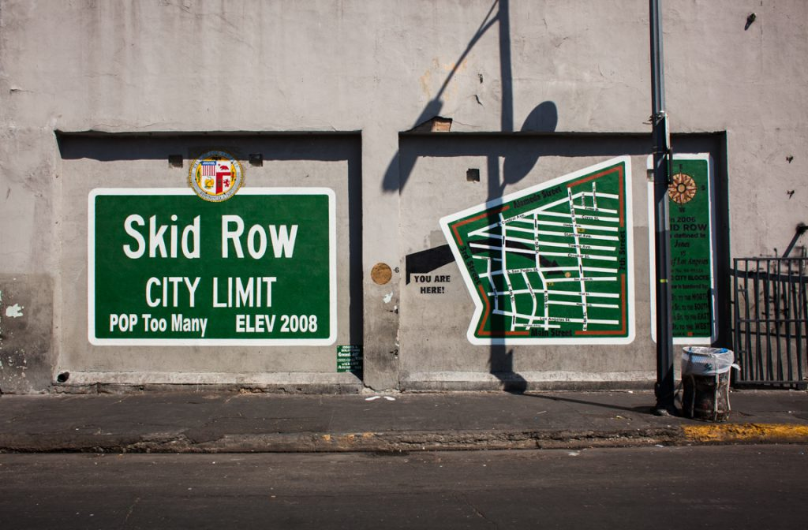

Black lives matter

* 1447 Lincoln Blvd, Santa Monica, California.

* La Cienega blv

Some street artists don’t credit their work, but their message isn’t any less powerful. Driving through downtown LA this large mural caught my eye I safely pulled out my phone at a red light and took a photograph. Kobe Bryant and Nipsey Hussle